

School of Computer Science & Engineering

SC2006 Software Engineering

Project Name: **ParkAnywhere**



**Team Ryan**

Lab 5

Team Members:

**Ryan Teo Cher Kean** (Leader) U2122540D

**Bryan Lee Wei Han** U2121789E

**Chow Wei Jie** U2121056D

**Chua Boon Chong, Jaedon** U2122153J

**Colin Jun Meehan** U2120168L

**Donna Chua** U2121254E

1. **Use Case Diagram**

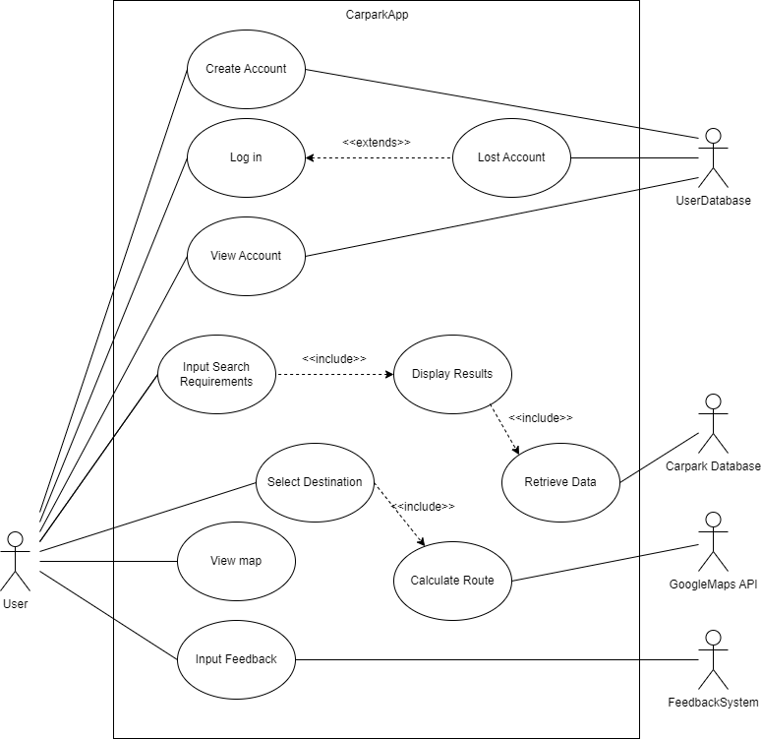

2. **Use Case Descriptions**

| **Use Case ID:** | 1 | | |
| --- | --- | --- | --- |
| **Use Case Name:** | Create Account | | |
| **Created By:** | Ryan Teo | **Last Updated By:** | Ryan Teo |
| **Date Created:** | 6th February 2023 | **Date Last Updated:** | 9th February 2023 |

| **Actor:** | User (Initiating Actor), UserDatabase |
| --- | --- |
| **Description:** | User can create an account to use, which is stored in the UserDatabase |
| **Preconditions:** | 1. Mobile must be connected to WiFi/Mobile Data. 2. UserDatabase must be up and running. |
| **Postconditions:** | 1. User creates an account with a unique username and password 2. User notified why they were unable to successfully create an account |
| **Priority:** | High |
| **Frequency of Use:** | - |
| **Flow of Events:** | 1. User opens app. 2. User selects the option “Create Account”. 3. User sets a unique username. 4. User sets a unique password with at least 8 characters, 1 capital letter, 1 number and 1 symbol. 5. New User account is stored in UserDatabase. 6. User account is linked to a mobile number/email. 7. User is logged in and moved to the main screen. |
| **Alternative Flows:** | AF-S3: Username already in use.   1. User inputs a username that is already in use. 2. System displays error message “Username already in use. Please choose another username.” 3. System returns to step 3   AF-S4: Password did not meet requirements.   1. User inputted a password that did not meet the requirements. 2. System displays error message “Password did not meet the requirements. Please input a password with at least 8 characters, 1 capital letter, 1 number and 1 symbol.” 3. System returns to step 4. |
| **Exception:** | EX-1: User repeatedly attempts to register for an account more than ten times despite errors in inputs.   1. On the 11th attempt, when the User chooses “Create Account”, the system displays the message “Too many attempts. Please try again in 10 minutes.” 2. The “Create Account” button is unavailable for ten minutes. 3. The system only accepts registration from the App User’s IP address after ten minutes. |
| **Includes:** | - |
| **Special Requirements:** | - |
| **Assumptions:** | - |
| **Notes and Issues:** | - |

| **Use Case ID:** | 2 | | |
| --- | --- | --- | --- |
| **Use Case Name:** | Log in | | |
| **Created By:** | Ryan Teo | **Last Updated By:** | Ryan Teo |
| **Date Created:** | 6th February 2023 | **Date Last Updated:** | 9th February 2023 |

| **Actor:** | User (Initiating Actor), UserDatabase |
| --- | --- |
| **Description:** | User wants to log in to the app. |
| **Preconditions:** | 1. User account must already exist in the database. 2. Mobile must be connected to WiFi/Mobile Data. |
| **Postconditions:** | 1. User logs in to app. 2. User’s account is locked due to too many login attempts |
| **Priority:** | Medium |
| **Frequency of Use:** | - |
| **Flow of Events:** | 1. User opens app. 2. User chooses the log in option. 3. User inputs a username and password and selects “Login” 4. System checks username and password against UserDatabase. 5. User successfully logs in. |
| **Alternative Flows:** | AF-S4: System detects an invalid username or password.   1. When the User selects “Login”, the system displays the message “Invalid username and/or password.” 2. The system returns to Step 4. |
| **Exception:** | EX-1: The User inputs incorrect username or password more than five times.   1. On the sixth attempt at logging in, when User clicks on “Login”, the system displays the message “Account suspended. Please try again after 10 minutes.” 2. The “Login” button is unavailable for ten minutes. 3. The system only accepts registration from the User’s IP address after ten minutes.   EX-2: The App User forgot his/her login credentials .   1. The App User clicks on “Forgot Username/Password” on the login page. 2. User can recover their account using extended use case Lost Account |
| **Includes:** | - |
| **Extends:** | 1. Lost Account |
| **Special Requirements:** | - |
| **Assumptions:** | - |
| **Notes and Issues:** | - |

| **Use Case ID:** | 3 | | |
| --- | --- | --- | --- |
| **Use Case Name:** | Lost Account | | |
| **Created By:** | Ryan Teo | **Last Updated By:** | Ryan Teo |
| **Date Created:** | 6th February 2023 | **Date Last Updated:** | 9th February 2023 |

| **Actor:** | User (Initiating Actor), UserDatabase |
| --- | --- |
| **Description:** | User forgot their username/password and wants to recover their account. |
| **Preconditions:** | 1. Mobile must be connected to WiFi/Mobile Data. 2. User must already have an existing account. 3. UserDatabase must be up and running. |
| **Postconditions:** | 1. User successfully recovers their account details. 2. User is locked out due to too many recovery attempts. |
| **Priority:** | Medium |
| **Frequency of Use:** | - |
| **Flow of Events:** | 1. User opens app. 2. User selects “Forgot Username/Password” option. 3. User is brought to account recovery page. 4. User is prompted to input their registered mobile number/email. 5. UserDatabse is checked for matching mobile number/email. 6. Account recovery instructions are sent to User’s mobile number/email. 7. User resets username/password. 8. User successfully recovers account details. 9. New details are saved in UserDatabase. 10. User is returned to login page. |
| **Alternative Flows:** | AF-S5: Invalid mobile number/email.   1. Inputted mobile number/email is unable to be retrieved from UserDatabase. 2. System displays error message “Invalid mobile number/email. Please try again.” 3. User is returned to step 4. |
| **Exception:** | EX-1: User attempts to recover account details more than 3 times.   1. On the fourth attempt, the system displays “Account suspended. Please try again after 10 minutes.” 2. The “Forgot Username/Password” button is unavailable for ten minutes. 3. The system only accepts registration from the User’s IP address after ten minutes. |
| **Includes:** | - |
| **Special Requirements:** | - |
| **Assumptions:** | - |
| **Notes and Issues:** | - |

| **Use Case ID:** | 4 | | |
| --- | --- | --- | --- |
| **Use Case Name:** | View Account | | |
| **Created By:** | Ryan Teo | **Last Updated By:** | Ryan Teo |
| **Date Created:** | 6th February 2023 | **Date Last Updated:** | 9th February 2023 |

| **Actor:** | User (Initiating Actor), UserDatabase |
| --- | --- |
| **Description:** | User wants to view account details and history (previous journeys etc.) |
| **Preconditions:** | 1. User account must already exist in the database. 2. Mobile must be connected to WiFi/Mobile Data. |
| **Postconditions:** | 1. User is able to retrieve account information. |
| **Priority:** | Medium |
| **Frequency of Use:** | - |
| **Flow of Events:** | 1. User taps on account icon. 2. System displays user information. |
| **Alternative Flows:** | - |
| **Exception:** | EX-1: User has not logged any information.   1. When user tries to look for information in the user account page, no information is displayed. 2. The message “No information.” is displayed. |
| **Includes:** | - |
| **Special Requirements:** | - |
| **Assumptions:** | - |
| **Notes and Issues:** | - |

| **Use Case ID:** | 5 | | |
| --- | --- | --- | --- |
| **Use Case Name:** | Input Search Requirements | | |
| **Created By:** | Ryan Teo | **Last Updated By:** | Colin |
| **Date Created:** | 6th February 2023 | **Date Last Updated:** | 9th February 2023 |

| **Actor:** | User |
| --- | --- |
| **Description:** | User wants to find a suitable car park, inputs search requirements to System. |
| **Preconditions:** | 1. User account must already exist in the database. 2. Mobile must be connected to WiFi/Mobile Data. |
| **Postconditions:** | 1. User is able to retrieve a list of carparks. 2. User is able to select a carpark to set as a location. |
| **Priority:** | Medium |
| **Frequency of Use:** | - |
| **Flow of Events:** | 1. User taps on the search bar. 2. User inputs his desired location into the search bar. 3. User adjusts the filter based on his priority for the best car park. 4. System returns a list of car parks. |
| **Alternative Flows:** | AF-S2: Desired location not found.   1. System displays the message “No matching locations.” 2. User is returned to step 2. |
| **Exception:** | - |
| **Includes:** | 1. Display Results |
| **Special Requirements:** | - |
| **Assumptions:** | - |
| **Notes and Issues:** | - |

| **Use Case ID:** | 6 | | |
| --- | --- | --- | --- |
| **Use Case Name:** | Display Results | | |
| **Created By:** | Ryan Teo | **Last Updated By:** | Colin |
| **Date Created:** | 6th February 2023 | **Date Last Updated:** | 9th February 2023 |

| **Actor:** | System |
| --- | --- |
| **Description:** | System filters results based on the specified search requirements by the User and displays them. |
| **Preconditions:** | 1. Mobile must be connected to WiFi/Mobile Data. 2. User’s search requirements are valid. 3. Carpark Database is up and running. |
| **Postconditions:** | 1. Relevant results are displayed to the User by the System. 2. No relevant results are found. |
| **Priority:** | Medium |
| **Frequency of Use:** | - |
| **Flow of Events:** | 1. System receives input from User. 2. System sends input to Carpark Database. 3. System retrieves relevant results from Carpark Database. 4. System displays results to User. |
| **Alternative Flows:** | AF-S3: Input does not return any results from Carpark Database.   1. Carpark Database returns “null” to System. 2. System displays error message “No carparks found with those search requirements. Please refine your requirements.” 3. Return to Step 1. |
| **Exception:** | - |
| **Includes:** | 1. Retrieve Data |
| **Special Requirements:** | - |
| **Assumptions:** | - |
| **Notes and Issues:** | - |

| **Use Case ID:** | 7 | | |
| --- | --- | --- | --- |
| **Use Case Name:** | Select Destination | | |
| **Created By:** | Ryan Teo | **Last Updated By:** | Colin |
| **Date Created:** | 6th February 2023 | **Date Last Updated:** | 9th February 2023 |

| **Actor:** | User |
| --- | --- |
| **Description:** | After System returns a list of suitable car parks, the User selects a destination based on that list. |
| **Preconditions:** | 1. Mobile must be connected to WiFi/Mobile Data. 2. System must have returned a list with carparks for the User to choose from. |
| **Postconditions:** | 1. User selects a destination from the list. 2. User does not like the options suggested and chooses to edit his search requirements. |
| **Priority:** | Medium |
| **Frequency of Use:** | - |
| **Flow of Events:** | 1. System returns a list of carparks for User to choose from. 2. User selects a carpark as their destination. 3. System assigns that carpark location as the destination. |
| **Alternative Flows:** | AF-S2: User wants to edit his search after seeing the results   1. User clicks on the search bar to re-enter search requirements. 2. User inputs his search requirements. 3. System retrieves search results from Carpark Database. 4. System displays search results. 5. Return to Step 2. |
| **Exception:** | - |
| **Includes:** | 1. Calculate Route |
| **Special Requirements:** | - |
| **Assumptions:** | - |
| **Notes and Issues:** | - |

| **Use Case ID:** | 8 | | |
| --- | --- | --- | --- |
| **Use Case Name:** | Calculate Route | | |
| **Created By:** | Ryan Teo | **Last Updated By:** | Colin |
| **Date Created:** | 6th February 2023 | **Date Last Updated:** | 9th February 2023 |

| **Actor:** | System |
| --- | --- |
| **Description:** | After User has selected a destination, System will determine the best route to take to get there. |
| **Preconditions:** | 1. Mobile must be connected to WiFi/Mobile Data. 2. User has inputted their intended destination. 3. System is able to detect User’s starting location. |
| **Postconditions:** | 1. System is able to calculate a relevant route to the intended destination from the starting location. |
| **Priority:** | Medium |
| **Frequency of Use:** | - |
| **Flow of Events:** | 1. System registers the destination chosen by the User. 2. System retrieves the starting location of the User based on mobile phone GPS. 3. System generates route using Google Maps API. |
| **Alternative Flows:** | - |
| **Exception:** | - |
| **Includes:** | - |
| **Special Requirements:** | - |
| **Assumptions:** | - |
| **Notes and Issues:** | - |

| **Use Case ID:** | 9 | | |
| --- | --- | --- | --- |
| **Use Case Name:** | Retrieve Data | | |
| **Created By:** | Ryan Teo | **Last Updated By:** | Colin |
| **Date Created:** | 6th February 2023 | **Date Last Updated:** | 9th February 2023 |

| **Actor:** | System (Initiating Actor), Carpark Database |
| --- | --- |
| **Description:** | System retrieves necessary info from the Carpark Database so it can generate results for suggested carpark. |
| **Preconditions:** | 1. System receives a request for data from User. |
| **Postconditions:** | 1. System receives relevant data from Carpark Database. 2. System is unable to receive relevant data from Carpark Database. |
| **Priority:** | Medium |
| **Frequency of Use:** | - |
| **Flow of Events:** | 1. System sends input requirements to Carpark Database. 2. Carpark Database is searched based on the requirements and returns all relevant results to the System. 3. System consolidates all results and displays them for the User. |
| **Alternative Flows:** | AF-S2: Carpark Database is unable to find any suitable results.   1. Carpark Database returns “null” to System. 2. System displays the error message “No carparks found with those search requirements. Please refine your requirements.” 3. Return to Step 1. |
| **Exception:** | - |
| **Includes:** | - |
| **Special Requirements:** | - |
| **Assumptions:** | - |
| **Notes and Issues:** | - |

| **Use Case ID:** | 10 | | |
| --- | --- | --- | --- |
| **Use Case Name:** | View Map | | |
| **Created By:** | Ryan Teo | **Last Updated By:** | Ryan Teo |
| **Date Created:** | 6th February 2023 | **Date Last Updated:** | 9th February 2023 |

| **Actor:** | User (Initiating Actor), System |
| --- | --- |
| **Description:** | System displays map information on the screen. |
| **Preconditions:** | 1. Mobile must be connected to WiFi/Mobile Data. |
| **Postconditions:** | 1. System calculates routes and displays them with the map of Singapore. 2. System is unable to calculate a route. |
| **Priority:** | Medium |
| **Frequency of Use:** | - |
| **Flow of Events:** | 1. User opens app and logs in. 2. System retrieves User’s current location using mobile phone GPS. 3. System displays the map of Singapore centred around User’s location. |
| **Alternative Flows:** | AF-S2: System cannot retrieve location information.   1. System is unable to retrieve current location. 2. System displays map centred around last known location. |
| **Exception:** | - |
| **Includes:** | - |
| **Special Requirements:** | - |
| **Assumptions:** | - |
| **Notes and Issues:** | - |

| **Use Case ID:** | 11 | | |
| --- | --- | --- | --- |
| **Use Case Name:** | Input Feedback | | |
| **Created By:** | Ryan Teo | **Last Updated By:** | Jaedon |
| **Date Created:** | 6th February 2023 | **Date Last Updated:** | 16th April 2023 |

| **Actor:** | User |
| --- | --- |
| **Description:** | User wants to input feedback on a specific car park or on the CarparkApp. |
| **Preconditions:** | 1. Mobile must be connected to WiFi/Mobile Data. 2. User must be logged in. |
| **Postconditions:** | 1. User feedback is uploaded. |
| **Priority:** | Medium |
| **Frequency of Use:** | 0-5 times a day |
| **Flow of Events:** | 1. User chooses feedback section. 2. System displays list of previously used carparks. 3. User chooses car park to rate. 4. User inputs rating out of 5. 5. User inputs comments for the rating. 6. System will display feedback for user to confirm. 7. User chooses to confirm. 8. System will upload feedback to Feedback System. |
| **Alternative Flows:** | AF-S2 : User has no parking history.   1. System displays text “No parking history found”. 2. User locked from sending in feedback with “Submit”   AF-S3 : User does not select a car park, input a rating nor a comment.   1. User locked from sending in feedback with “Submit” |
| **Exception:** | - |
| **Includes:** | - |
| **Special Requirements:** | - |
| **Assumptions:** | - |
| **Notes and Issues:** | - |

3. **Class Diagram**

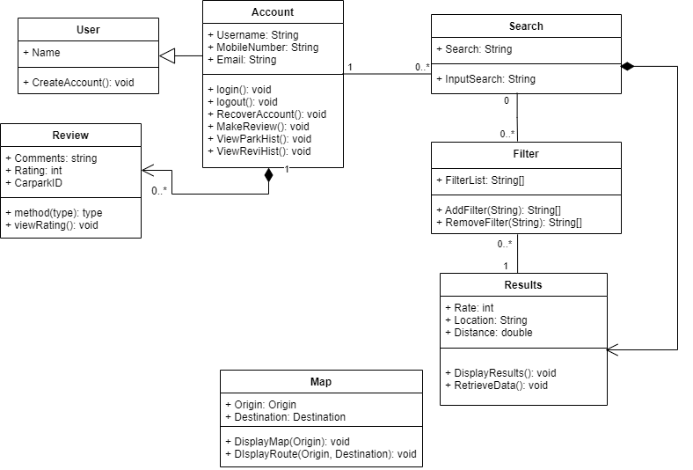

4. **Key Boundary Classes and Control Classes**

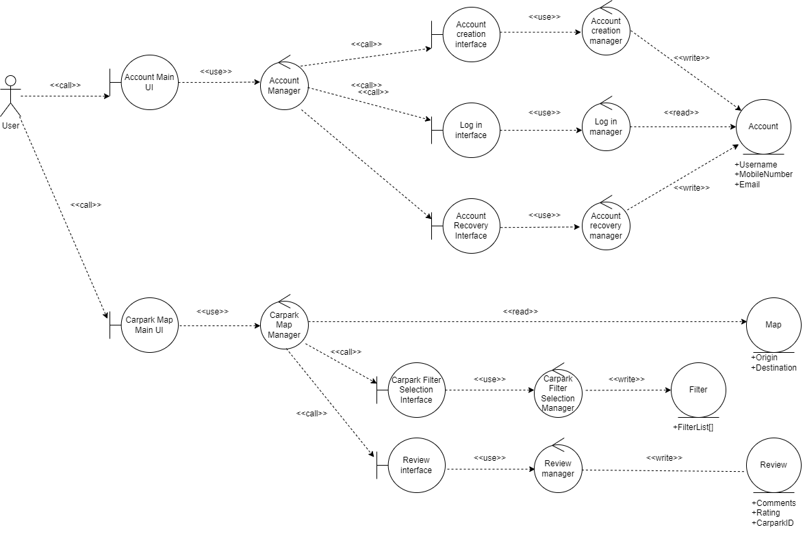

5. **Sequence Diagrams**

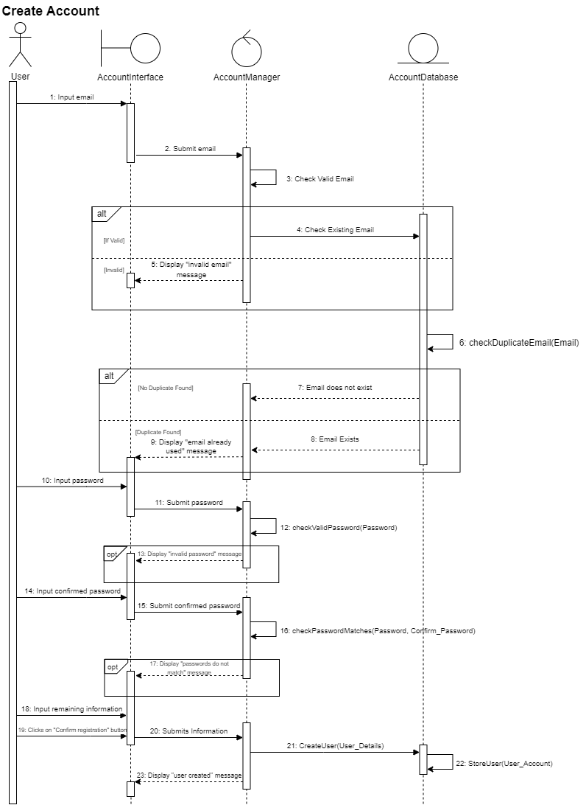

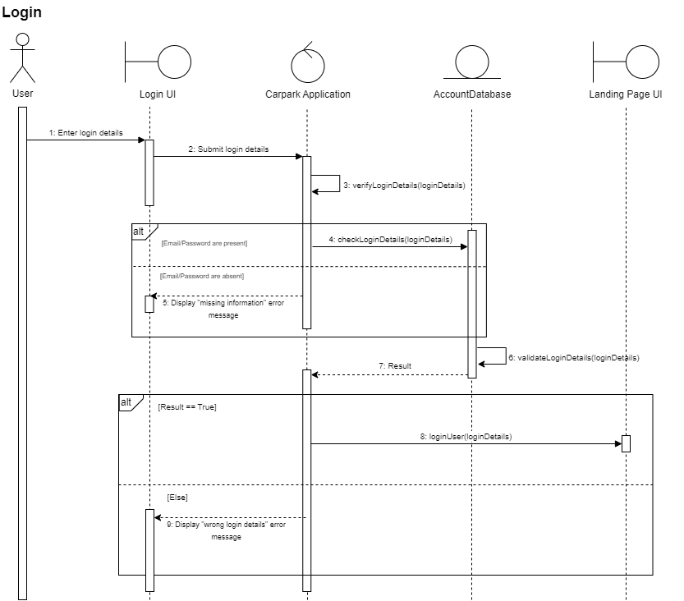

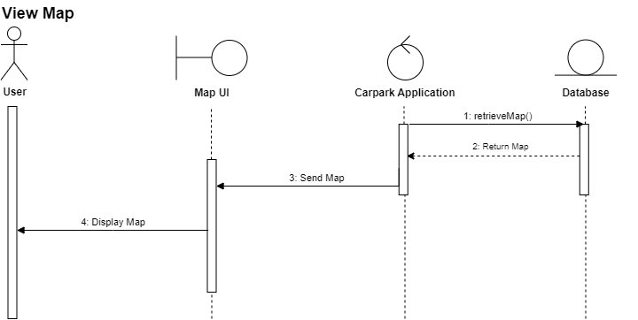

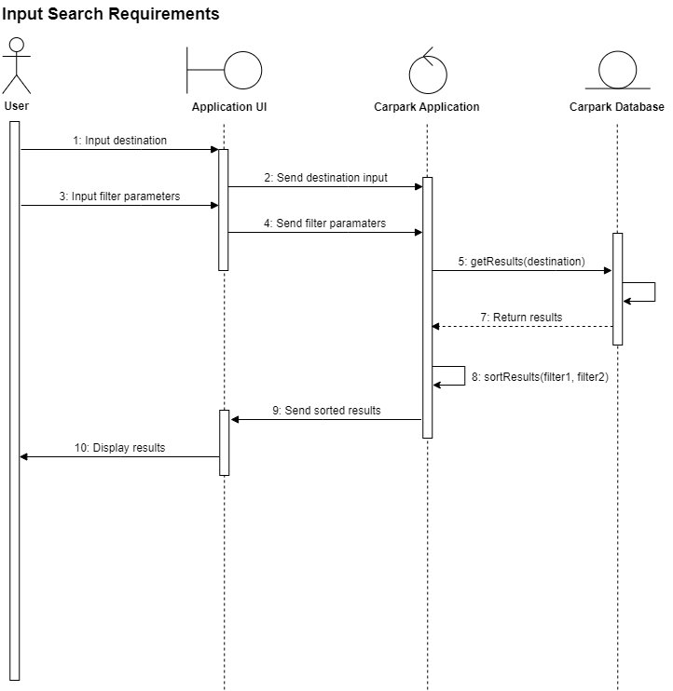

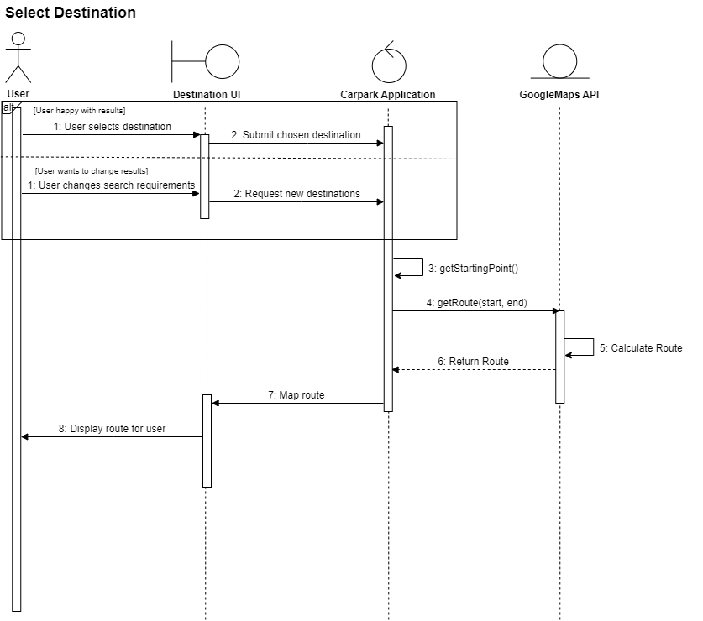

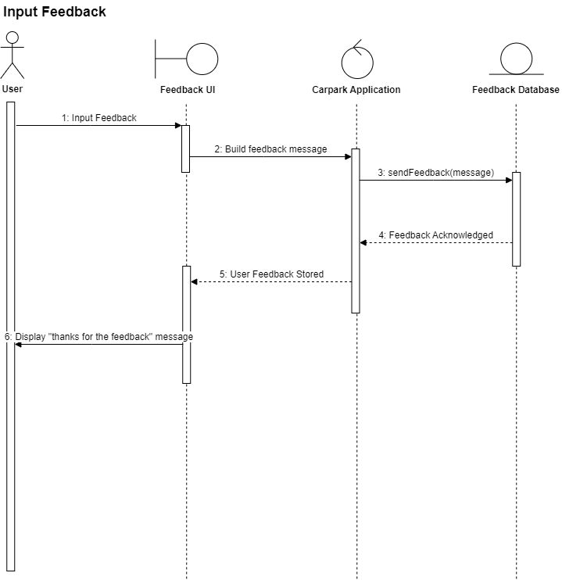

6. **Dialog Map**

